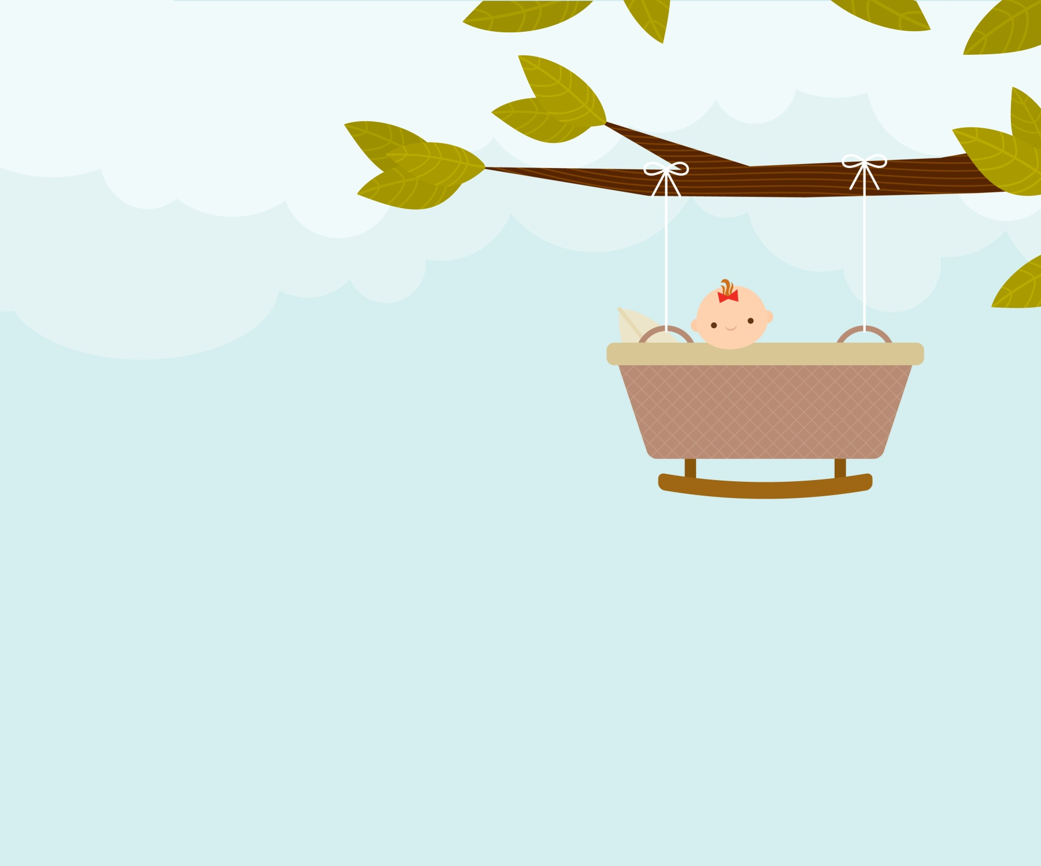

**One Birth, One Tree**

Application form

|  |  |  |
| --- | --- | --- |
| IDENTIFICATION | | |
| Child’s name | |  |
| Name(s) of parent(s) | |  |
| Address | |  |
| Owner □ Tenant □ Part owner (condo) □ |
| Phone number | |  |
| Email address | |  |
| Date of birth / adoption of the child | |  |
| Proof of residence and identity □ Document certifying birth □ Proxy (if necessary) □ | | |
| preferred variety of tree to plant | | |
| □ | Red Jewel Crabapple- *Malus 'Red Jewel'* - H : 5m W : 4m | |
| □ | Leavis serviceberry- *Amelanchier laevis* - H : 8m W : 5m | |
| □ | Amur maackia- *Maackia amurensis* - H : 8m W : 6m | |
| □ | Common hackberry - *Celtis occidentalis* - H: 13m W : 10m | |
| □ | Maidenhair tree - *Ginkgo biloba* - H : 20m W : 13m | |
| preferred location to plant the tree | | |
| □ | I wish the tree to be delivered to me at home and I will take care of planting the tree on my property. | |
| □ | I wish the tree to be planted on land belonging to the Town of Kirkland. | |

|  |  |
| --- | --- |
| □ | I would like to register my baby (0-12 months) to the Kirkland Library and receive a gift bag “Books for Baby”. |

I, _______________________________, agree to comply with all terms and conditions governing the program « One Birth, One Tree ».

Parent’s signature: ___________________________________ Date: _________________





**One Birth, One Tree**

Terms and conditions

As part of its new program « One Birth, One Tree », the Town of Kirkland is proud to give new Kirkland parents the opportunity to celebrate baby’s arrival by planting a tree to grow at his/her side, on their own property or, if they prefer, in a city park or green space. For any questions or to apply for the program, please contact:

Alexandre Gervais – Section Head – Environment

25, rue Claude-Jodoin, Kirkland (Québec) H9H 5E6

Phone: 514 694-4100, ext. 3414

Email: agervais@ville.kirkland.qc.ca

**Terms and conditions of the Program:**

* To qualify for the program, the applicant must reside in Kirkland at the time of the birth or adoption and apply to the program within twelve (12) months of the date of birth or adoption.
* Applications must be submitted with a proof of the birth or adoption of the child as well as a proof of identity and residence of the applying parents.
* In all cases, it is up to the program coordinator to determine whether the chosen variety and/or planting location are suitable for that specific area.
* The Town cannot guarantee that the tree species selected will be available at the time of application. Should this happen, another tree species will be suggested.
* The owner is entirely responsible for maintenance of the tree planted on his private property and it is prohibited to move the tree to another private property.
* The Town remains the owner of any tree planted on one of its properties.
* Where the applicant is not the owner of the land upon which the tree is to be planted, a proxy form duly signed by said owner must accompany the application.
* One tree per child only.